[Project Name]
[Workstream]
Hive Best Practices Document

VERSION HISTORY

Version | Implemented By | Revision Date | Approved By | Approval Date | Description of Change
1.0 | ABC | dd/mm/yyyy | XYZ | dd/mm/yyyy | Original Copy

Purpose

The purpose of this document is to provide standard conventions and guidelines to follow when creating Hive code.

Background

This is a reusable guide that will not need to be configured on a project-by-project basis. As can be seen in Figure 1, Hive sits on the side of the Hadoop Automation and Ingestion Framework, and is not a direct input into any of the processes.
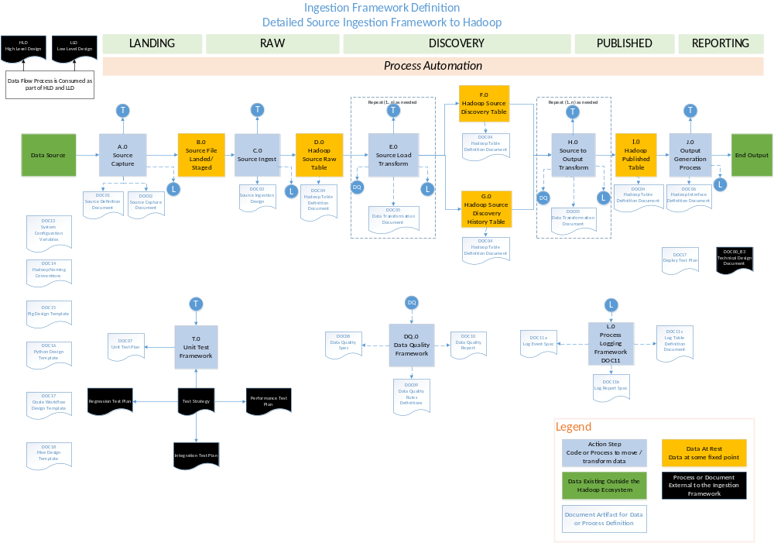
Figure 1 Hadoop Ingestion and Automation Framework

Hive Best Practices

Partitioning Tables:
The selection of partition key is always a sensitive decision, it should always be a low cardinal attribute, e.g. if your data is associated with time dimension, then date could be a good partition key. If your data is associated with Locations like city,country,state etc. at that time we can partitioning the data by the location column in hierarchy.
- Pick a column with low-medium NDV
- Avoid Partitions < 1GB, bigger is better
- Nesting can cause too many partitions
- Scale: For dates, use partitions that increase scale as data gets older, e.g. 15 minutes, hours, months, year …

De-normalizing data:
Normalized data is high level data (like some rules). It also deals with data redundancy (duplication). Generally joins are very useful concepts but Joins are very difficult and expensive operations to perform and also one of the reasons for performance issues. The cost/benefit balance for normalization is different for Hive, resulting in much less emphasis on normalization, and in some cases, even in deliberate de-normalizing data imported from highly normalized relational sources. Some of the reasons are:
- The use-cases are for Hive are analytic and not transactional
- Normalization as a tool for maintaining consistency tends to be less important
- The many-way joins required for normalized data tend to be more expensive for Hive
- Hive’s massive parallelism eliminates many of the disk-I/O limitations of an RDBMS, reducing the value of normalization for reducing data volume.
- Hive is often used with data volumes for which it would be impractical to use normalized data.
  - It is common to drop anywhere from gigabytes to terabytes of data into HDFS and expect it to be accessible through Hive almost instantly.

3. Compress map/reduce output:
Compressing techniques are used to reduce or decrease the size of Intermediate data. This technique internally reduces the amount of transferring data between mappers and reducers. This all happens over the network. This compression technique is applied separately on mappers and Reducers.gzip compressed files are not splittable.snappy, lzo, bzip, etc other options of compression.
- For map output compression set mapred.compress.map.output to true
- For job output compression set mapred.output.compress to true

Map join:
Map Joins are very useful when the hive table on the other side of a join is small enough to fit in the memory.Hive supports a parameter, hive.auto.convert.join, which when it’s set to “true” suggests that Hive try to map join automatically. When using this parameter, be sure the auto convert is enabled in the Hive environment.

Bucketing:
Bucketing improves the join performance if the bucket key and join keys are common. The table divide into number of partitions, The Hive Partition can be further subdivided into Clusters or Buckets.
  - Use only for very large tables
  - Get the distribution of data correct
  - Use the right bucket number
Note: Only use to get joins on bucket key

Input Format Selection:
Input formats are playing very important role in Hive performance.Primary choices of Input Format are Text,Sequence File,RC File,ORC .Detailed Information and difference between Text,Sequence File,RC File,ORC click here

Text Input Format :-
i) Default,Json,CSV formats are available
ii) Slow to read and write
iii) Can’t split compressed files (Leads to Huge maps)
iv) Need to read/decompress all fields.

Sequence File Input Format :-
i) Traditional map reduce binary file format
a) Stores Keys and Values as a class
b) Not good for Hive ,Which has sql types
c) Hive always stores entire line as a value
ii) Default block size is 1 MB
iii) Need to read and Decompress all the fields

RC (Row Columnar File )Input Format :-
i) columns stored separately
a) Read and decompressed only needed one.
b) Better compression
ii) Columns stored as binary Blobs
a) Depend on Meta store to supply Data types
iii) Large Blocks
a) 4MB default
b) Still search file for split boundary

ORC (Optimized Row Columnar)Input Format :-
i) column stored separately
ii) Knows Types
a) Uses Types specific en-coders
b) Stores statistics (Min,Max,Sum,Count)

Parallel execution:
Hadoop can execute MapReduce jobs in parallel, many queries in hive also executed by using this parallel execution concept we can utilize the performance of our hadoop cluster and reduce the query execution time also improve the performance The configuration in Hive to change this behavior is merely switching a single flag SET hive.exec.parallel=true.

Vectorization:
Generally Hive allows processing one row at a time but Vectorization allows Hive to process a batch of rows together instead of processing one row at a time.which improves the instruction pipelines and cache usage. To enable vectorization, set this configuration parameter SET hive.vectorized.execution.enabled=true.

Unit Testing:
Unit Testing is nothing but Testing the small piece of code works exactly as you expect or not.By using with Unit Testing we can easily find out the errors and easily re modify the code also.In Hive, you can unit test UDFs, SerDes, streaming scripts, Hive queries and more.By using this Unit Testing we can save huge amount of time.There are several tools available that helps you to test Hive queries. Some of them that you might want to look atHiveRunner, Hive_test and Beetest.

Sampling:
Sampling is nothing but just try the query on some amount of sample data without having to analyze the entire data set Then a query can return meaningful results as well as finish quicker and consume fewer compute resources.

Guideline and design principle for Queries:
- Don’t forget to specify ORC storage in the DDL. Many of the most important optimizations require it, so it should be default format.
- Don’t try to use Hive like an OLTP system
  - Transactions in Hive are best used for adding data and batch updates, not supporting concurrent updates
  - There’s a separate file of deltas created for each transaction that changes the data—it is not a mechanism for high-frequency changes
  - HBase (the NoSQL database included in HDP) is also is not a relational database, but it can handle many of the high-frequency lookup use-cases far better than Hive (and in some use-cases, better than any RDBMS.)
- Joins are allowed in Hive, and are highly useful, but in general:
  - A good Hive schema will be less normalized than an RDBMS or OLAP schema, in large part to avoid joins.
  - Consider de-normalizing big normalized tables that have been ingested from RDBMS’s or OLAP systems. One way to do this is to:
    - Define a de-normalized version of the table in question
    - Define a view over multiple tables
    - Select everything in the view into your de-normalized table
    - If the table is often used in conjunction with other large tables, consider setting up the partitioning/bucketing on all the joined tables to match

  - If you’re using “dimension” tables, make sure you’ve enabled broadcast joins
  - Even if the query is entirely map-side, there is still a cost to a “star” configuration in the time and memory to build the maps, copying the dimension tables across the network, etc. Don’t use a star schema style unnecessarily.
  - If “rank” can be substituted for over “max()” in a subquery, you will avoid a join and usually speed up a query.
- Look out for skewed data (in which some columns in the where-clauses have values that are grossly over-represented). If some mappers seem to take much longer than others, it is often a symptom of skew.
  - Fix this in the DDL by creating the table with a “skewed by” column
  - “Skewed by” splits out rows with the skewed value into multiple files of their own so they can be processed in parallel.
  - If the data is already loaded, you can re-load the data by
    - Moving the data to a temporary table
    - Recreating the real table with the corrected skewed-by properties
    - Inserting the data programmatically into the empty new table.
  - There is no point is using “skewed by” if the column does not appear in where clauses.
- Buckets and partitions are your friends
  - Partition and/or bucket large tables that joined frequently on the same column in the same way, in order to take advantage of physical locality
  - Sort the bucketed columns to increase pushdown predicate effectiveness—sorting allows the ORC reader to use metadata to ignore inapplicable row-groups more effectively
  - Don’t divide the data set so finely that you have under-sized blocks or splits
  - Minimize the depth of partitions—one or two at most unless your tables are huge
  - Beware that bucketing helps most when it
    - Enables effective predicate pushdown
    - Facilitates bucket-joins
    - Can be used for sampling
- Consider increasing the replication factor for dimension tables that are heavily used
  - This is done at the HDFS level, not at the Hive level
  - It may be worth it to replicate small heavily used dimension tables—up to several megabytes—to every node in the cluster.
- When using CPU-intensive formats such as XML or JSON, it may be more economical to write a temporary extract of the data to ORC format and then execute your query than to execute your query against the raw data.
- Consider “roll-ups” for large frequently queried datasets, i.e., pre-computed aggregations and summaries
- Views are handy, but beware that they are pure metatdata—they are not materialized, and represent implicit computation

Controlling the number of Mappers
- The maximum number of mappers per hardware node can be limited by controlling the memory allocated to Tez containers. The ratio of these two is the maximum number of mappers per node.
  - yarn.nodemanager.resource.memory—mb
  - yarn.scheduler.minimum.allocation-mb
- The typical ratio should be around containers per disk or core.
- Number of disks and number of cores should be in the same ballpark on a well-tuned commodity hardware cluster

Data Loading Options:
- Dropping data files into HDFS from outside of Hive
  - Directly copying files into HDFS using the hdfs or hadoop utilities, WebHDFS, or HDFS nfsmount.
  - Data may be
    - Directly dropped into the Hive table’s HDFS data warehouse directory
    - Copied into an HDFS staging directory, then loaded into Hive using the “LOAD” command, which simply adjusts the HDFS links to move the files into the Hive data warehouse directory.
  - Using the Hadoop “distcp” utility to do a distributed copy that accomplishes the processes described
    - Copy data from HDFS on one cluster to HDFS on another
    - Copy data within a cluster from one HDFS directory to another
    - Copy data from a native file system to HDFS
  - Using Apache Flume to automate the process of moving bulk files
  - Flume can also “tail” files, such as log files, appending the data to the files backing a Hive table continuously.
  - Using Sqoop automates the process of downloading data from a relational source and inserting the resulting data into hive directories.
- Using Hive to insert data into a Hive table
  - Data is selected from one set of tables using a Hive SQL, and inserted into another Hive table. This is often used to convert raw data (e.g., a CSV file) into a table backed by ORC, possibly with columns rearranged, deleted, cleaned up, etc.
  - The underlying process is distributed MapReduce or Tez, and result is data files dropped into the Hive data warehouse HDFS directories.
- Streaming processes
  - Hive supports streaming in data from Storm and other sources and inserting it into a Hive table. The result is, once again, big data block files in the Hive warehouse HDFS directories.

Cost Based Optimization :
Until the advent of the Cost Based Optimizer (CBO) Hive used more-or-less hard-coded strategies to generate a specific query plan. The CBO lets Hive tune up the query plan according to metadata that has been gathered in advance from the data. This has long been a feature of any RDBMS worth its salt, but it’s relatively new to Hive. Table statistics used by the CBO include min, max, number of distinct values, partitions, table DDL, and so on, to optimize the query plan. Turning on CBO will typically halve the execution time for a query, and may do much better than that.
To Use CBO
  - SET hive.cbo.enable=true;
  - SET hive.stats.fetch.column.stats=true;
  - SET hive.stats.fetch.partition.stats=true;
It Helps especially with Joins

